Take-Home Project

Assume we have a third party reporting application outputting numerous reports meant for clients. Create a C# service application that collects these reports and moves and/or emails to various destinations grouped by clients. The C# application will read an XML configuration file similar to the one below,

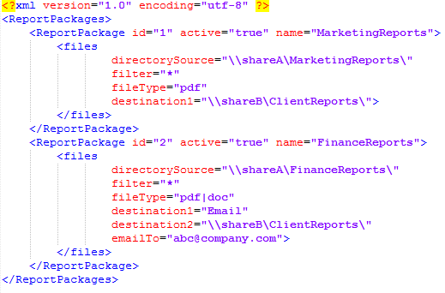

1. Read all files from directorySource with the specified filter and fileType.
2. In order to group the reports by client, connect to an MS SQL Server database and retrieve results from the following database structure to correctly map and create a destination folder structure.
   1. Account Table: id, name, code
   2. Client Table: id, name, code
   3. Account Client Relationship accountId, clientId

Sample Results:  
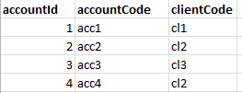

Note: There can be multiple accounts for 1 client.

1. Assume files from all source directories will have the following naming conventions (AccountCode+ReportDate+FileExtenstion),

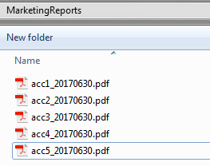

1. Create the following folder structure with year/month/clientcode and copy the reports to their respective client folders.

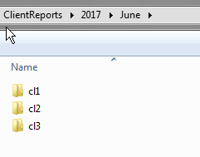

**Additional Notes/Extensions**

* Consider running the ReportPacakges in parallel.
* Use LINQ where applicable.
* Ability to extend to multiple destination types (i.e., destination1, destination2, destination3, ...).
* In the case of emailing, zip the files into 1 zip per client.